DROP OFF

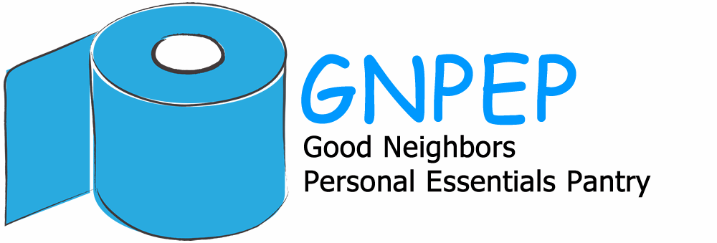
ITEMS HERE
PANTRY PRODUCTS NEEDED

Any Size Package

Toilet paper
Paper towels
Kleenex
Emery board
Dental floss
Toothbrushes (child & adult)
Lip balm
Razors
Band aids
Antibiotic Cream
DIAPERS( all sizes but especially larger)
PULL-UPS (all sizes)
Tampons (Regular only)
Sanitary Pads (Super only)
Panti-liners

Defined Size

Must be AT LEAST the size indicated
laundry detergent, liquid (>32 loads)
Dish Soap (14 oz)
Vinegar (16 oz)
Baking Soda (16 oz)
Toothpaste (6 oz)
Body bar soap (4 oz)
Shaving Cream (10 oz)
Skin lotion (10 oz)
Shampoo (12 oz)
Conditioner (12 oz)
Diaper Rash Ointment (4 oz)
Baby Wipes (72 count pack)

